Laboratoriya ishi №9
Mavzu: CAPTCHA yaratish va formaga integratsiya qilish
Ishning maqsadi
Talabalarga web-ilovalarda xavfsizlikni oshirish maqsadida CAPTCHA (Completely Automated Public Turing test to tell Computers and Humans Apart) yaratish va uni PHP yordamida forma bilan integratsiya qilishni o‘rgatish.
Nazariy qism
CAPTCHA nima?
CAPTCHA — bu foydalanuvchi inson ekanligini aniqlash uchun ishlatiladigan test bo‘lib, odatda avtomatlashtirilgan botlardan himoya qiladi.
CAPTCHA turlari:
- Matnli CAPTCHA (eng oddiy)
- Rasmli CAPTCHA
- reCAPTCHA (Google xizmati)

Kerakli vositalar
- PHP (>= 7.0)
- Apache yoki Nginx server (XAMPP/WAMP/OpenServer)
- Zamonaviy brauzer
- Amaliy qism
CAPTCHA generatsiya qilish (captcha.php)
<?php
session_start();

$captcha_text = substr(str_shuffle("ABCDEFGHJKLMNPQRSTUVWXYZ23456789"), 0, 6);
$_SESSION['captcha'] = $captcha_text;

$image = imagecreate(150, 50);
$bg_color = imagecolorallocate($image, 255, 255, 255);
$text_color = imagecolorallocate($image, 0, 0, 0);

imagestring($image, 5, 30, 15, $captcha_text, $text_color);

header("Content-type: image/png");
imagepng($image);
imagedestroy($image);
?>
HTML forma yaratish (index.php)
<?php session_start(); ?>
<!DOCTYPE html>
<html>
<head>
<title>CAPTCHA Form</title>
</head>
<body>

<form method="post" action="check.php">
<label>Ismingiz:</label><br>
<input type="text" name="name"><br><br>

<img src="captcha.php"><br><br>

<label>CAPTCHA kiriting:</label><br>
<input type="text" name="captcha"><br><br>

<button type="submit">Yuborish</button>
</form>

</body>
</html>
CAPTCHA tekshirish (check.php)
<?php
session_start();

if ($_POST['captcha'] == $_SESSION['captcha']) {
echo "To'g'ri CAPTCHA!";
} else {
echo "Noto'g'ri CAPTCHA!";
}
?>
Ishlash jarayoni
- Foydalanuvchi sahifani ochadi
- CAPTCHA rasm generatsiya qilinadi
- Foydalanuvchi kodni kiritadi
- PHP orqali tekshiriladi
- Natija chiqariladi

Muhim eslatmalar
- session_start() har doim ishlatilishi kerak
- CAPTCHA har safar yangilanib turishi kerak
- GD kutubxonasi yoqilgan bo‘lishi kerak (php.ini da)
Kutilayotgan natija
Talaba quyidagilarni bajara olishi kerak:
- CAPTCHA generatsiya qilish
- Session bilan ishlash
- Forma orqali ma’lumot yuborish
- Tekshirish mexanizmini yaratish

Nazorat savollari
- CAPTCHA nima va nima uchun ishlatiladi?
- PHP da session qanday ishlaydi?
- CAPTCHA xavfsizlikni qanday oshiradi?
- GD kutubxonasi nima vazifani bajaradi?
Topshiriqlar:
Login va Registratsiya forma yaratilsin va har bir formada captcha bo’lsin. Captcha talabalari harflardan iborat bolsin captcha dizayni boshqa captchalarga qaraganda har kimniki har hil bosin. Captchada birinchi talabanni {ismi-captcha} shaklida bo’lsin captcha ustiga bosganda captcha almashadigan va form submit berganda ham captcha almashadigan bo’lsin. Captcha almashganda formaga submit qilganda eski captcha hato deyishi kerak.

KOD

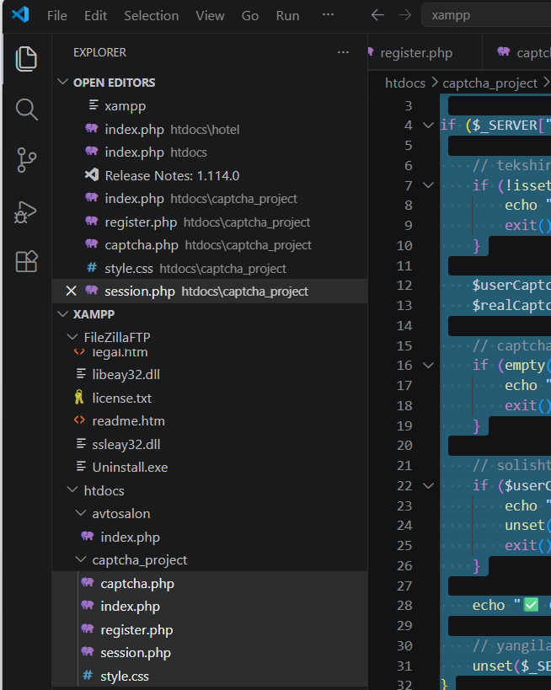

index.php (Login form)

<?php
session_start();
?>

<!DOCTYPE html>
<html>
<head>
<title>Login</title>
</head>
<body>

<h2>Login</h2>

<form method="POST" action="session.php">
<input type="text" name="username" placeholder="Username"><br><br>
<input type="password" name="password" placeholder="Password"><br><br>

<img src="captcha.php" id="captchaImg" onclick="refreshCaptcha()" style="cursor:pointer;"><br>
<small>Captcha ustiga bosing yangilash uchun</small><br><br>

<input type="text" name="captcha" placeholder="Captcha kiriting"><br><br>

<button type="submit">Login</button>
</form>

<script>
function refreshCaptcha() {
document.getElementById("captchaImg").src = "captcha.php?" + Date.now();
}
</script>

</body>
</html>

│── register.php (Registratsiya)

<?php session_start(); ?>

<h2>Register</h2>

<form method="POST" action="session.php">
<input type="text" name="name" placeholder="Ism"><br><br>
<input type="text" name="username" placeholder="Username"><br><br>
<input type="password" name="password" placeholder="Password"><br><br>

<img src="captcha.php" id="captchaImg2" onclick="refreshCaptcha2()" style="cursor:pointer;"><br><br>

<input type="text" name="captcha" placeholder="Captcha"><br><br>

<button type="submit">Register</button>
</form>

<script>
function refreshCaptcha2() {
document.getElementById("captchaImg2").src = "captcha.php?" + Date.now();
}
</script>

│── captcha.php (Captcha generator)

<?php
session_start();

header("Content-type: image/png");

$width = 150;
$height = 50;

$image = imagecreate($width, $height);

// Random ranglar
$bg_color = imagecolorallocate($image, rand(200,255), rand(200,255), rand(200,255));
$text_color = imagecolorallocate($image, rand(0,100), rand(0,100), rand(0,100));

// Random harflar
$chars = 'ABCDEFGHIJKLMNOPQRSTUVWXYZ';
$captcha = '';
for ($i = 0; $i < 6; $i++) {
$captcha .= $chars[rand(0, strlen($chars)-1)];
}

// Sessionga saqlaymiz
$_SESSION['captcha'] = $captcha;

// Shovqin (noise)
for ($i = 0; $i < 50; $i++) {
imagesetpixel($image, rand(0,$width), rand(0,$height), $text_color);
}

// Matn yozish
imagestring($image, 5, 30, 15, $captcha, $text_color);

imagepng($image);
imagedestroy($image);
?>

│── style.css (Dizayn)

/* Umumiy sahifa */
body {
margin: 0;
padding: 0;
font-family: Arial, sans-serif;
background: linear-gradient(135deg, #4facfe, #00f2fe);
height: 100vh;
display: flex;
justify-content: center;
align-items: center;
}

/* Forma konteyner */
.container {
background: #fff;
padding: 30px;
width: 320px;
border-radius: 10px;
box-shadow: 0 10px 25px rgba(0, 0, 0, 0.2);
text-align: center;
}

/* Sarlavha */
.container h2 {
margin-bottom: 20px;
}

/* Inputlar */
.container input {
width: 100%;
padding: 10px;
margin: 8px 0;
border-radius: 5px;
border: 1px solid #ccc;
outline: none;
transition: 0.3s;
}

/* Input fokus */
.container input:focus {
border-color: #4facfe;
}

/* Tugma */
.container button {
width: 100%;
padding: 10px;
background: #4facfe;
border: none;
color: white;
font-size: 16px;
border-radius: 5px;
cursor: pointer;
transition: 0.3s;
}

/* Hover */
.container button:hover {
background: #00c6ff;
}

/* Captcha rasm */
.captcha-img {
margin-top: 10px;
cursor: pointer;
border-radius: 5px;
border: 1px solid #ccc;
}

/* Matn */
small {
color: #555;
}

│── session.php (Captcha tekshiruv)

<?php
session_start();

if ($_SERVER["REQUEST_METHOD"] == "POST") {

// tekshiramiz captcha kelganmi
if (!isset($_POST['captcha']) || empty($_POST['captcha'])) {
echo "❌ Captcha kiritilmadi!";
exit();
}

$userCaptcha = $_POST['captcha'];
$realCaptcha = $_SESSION['captcha'] ?? '';

// captcha mavjudligini ham tekshiramiz
if (empty($realCaptcha)) {
echo "❌ Captcha eskirgan, qaytadan urinib ko‘ring!";
exit();
}

// solishtirish
if ($userCaptcha !== $realCaptcha) {
echo "❌ Captcha noto‘g‘ri!";
unset($_SESSION['captcha']); // eski captcha o‘chadi
exit();
}

echo "✅ Captcha to‘g‘ri!";

// yangilaymiz
unset($_SESSION['captcha']);
}
?>

Natija

